Ben Robinson

[Company name]  [Company address]

Simple Game Analysis

# Game 1 IQ Ball

Game can be found at: <https://www.coolmathgames.com/0-iq-ball>

Game Genre: 2d platformer

Controls: Left Click (Spawns arm)

Objective: Move Player Character to target

Observation: The Game is very simple and enjoyable. Player seems to move with velocity calculations due to the player not stopping immediately when colliding with a wall or when grabbing onto a new object. There are no lives or game overs within the game however the level can be reset if there is no way to progress forward. Game does track the number of clicks it took to finish a level allowing players to add a self-imposed challenge of beating a level in as little number of clicks as possible. 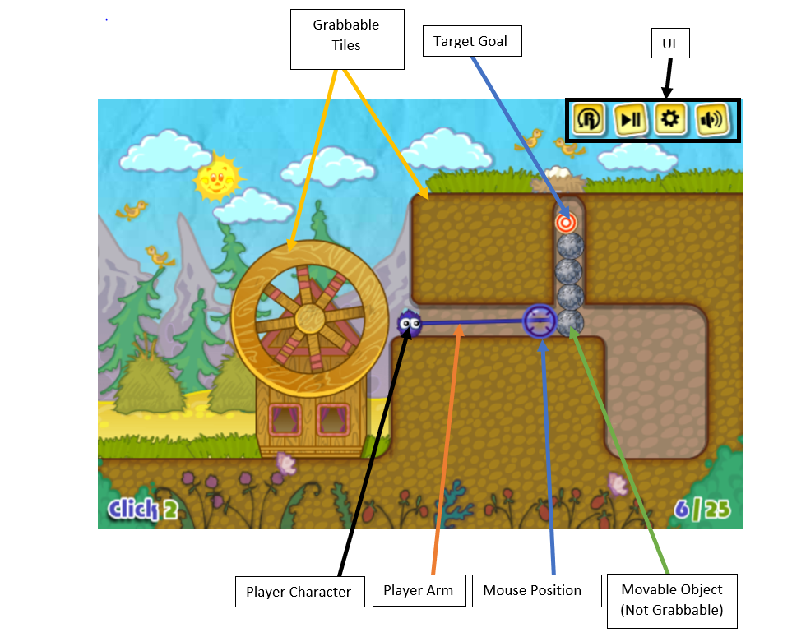

# Game 2: Factory Balls Forever

Game can be found at <https://www.coolmathgames.com/0-factory-balls-forever>

Game Genre: Puzzle

Controls: Left Click

Objective: Colour a blank ball to match the image shown by clicking on certain buttons in a certain order

Observation: Game is very simple in design only requiring the player to click a button however I am not too sure on how the ball object the player is painting is created, whether it is multiple images that change between each other depending on what the player decides to do or if textures are added on to each other to create a similar effect

Players Image

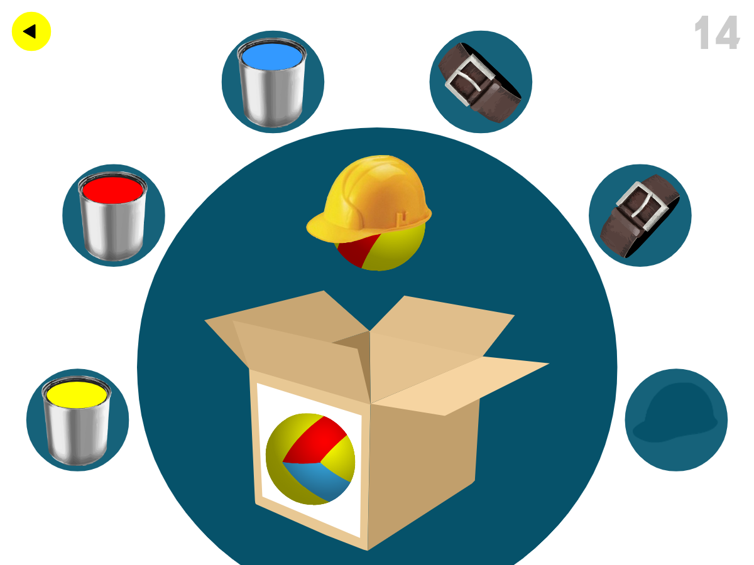

Add effect to Sphere

Goal

# Game 3: Mario Party the Top 100 Mini game 1: Shy Guy Says

Controls: L and R triggers

Description: Players must follow the instructions of a shy guy who will throw up flags matching the designated button